**Day 5 – Testing, Error Handling and Backend Integration Refinement**

**Objective:** The primary goal of Day 5 was to finalize the e-commerce marketplace for real-world deployment. This included rigorous testing, performance optimization, robust error handling, security enhancements, and detailed documentation to ensure a seamless user experience.

**1. Functional Testing:**

**Key Features Tested:**

**•** Cart Functionality:

• Increment and decrement product quantities in the cart.

• Remove items from the cart.

• Ensure cart updates reflect accurately in real-time.

• Checkout & Payment:

• Verified the complete checkout flow from cart to payment processing.

• Ensured order placement completes successfully with accurate details.

• Implemented confirmation prompts before proceeding with payment.

• User Authentication & Session Management:

• Tested signup, login, and logout functionalities.

• Verified OAuth-based authentication via Google Sign-In using Clerk.

• API Response Validation:

• Tested API responses under normal, slow, and failed network conditions.

• Ensured a fallback UI for empty or failed responses.

• Product Details Display:

• Ensured dynamic routing functions correctly for individual product pages.

• Link Navigation:

• Verified all internal and external links work as expected.

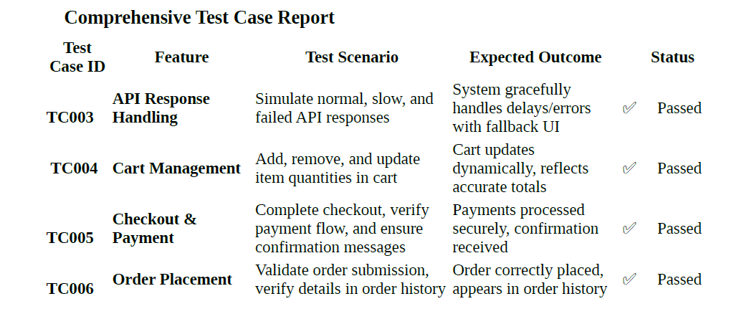

**Non-Functional Testing:**

**• Performance Testing:** Evaluated load times and optimized the backend for high-traffic

scenarios.

**• Stress Testing:** Simulated high user loads to measure system resilience.

**• User Acceptance Testing (UAT):** Gathered feedback from test users to improve usability**.**



**2. Error Handling Mechanisms**

**• API Error Handling:** Implemented try-catch blocks for all API calls, displaying user-friendly

messages (e.g., "Unable to load products. Please try again later.").

**• Error Message Display:** Ensured clear messaging for empty data responses (e.g., "No products found").

**• Network Error Management:** Tested scenarios with no internet connectivity to confirm

graceful degradation and retry mechanisms.

**•** Logging and Debugging: Integrated logging mechanisms to track API failures and backend

errors for future debugging.

**3. Performance Optimization.**

**•** Frontend Optimization:

• Implemented lazy loading for images and large components.

• Minimized unused CSS and JavaScript.

• Enabled code-splitting to improve page load speed.

• Backend Enhancements:

• Optimized database queries for faster API responses.

• Implemented server-side caching for frequently accessed data.

• Improved API response time under high-traffic scenarios.

• **Load Testing Results:**

• Faster initial page load time.

• Improved response time for database-heavy operations.



**4. Security Testing**

**•** Vulnerability Scanning: Conducted automated scans to identify potential security threats.

• Data Encryption: Implemented encryption for sensitive data, including user passwords and

payment details.

• Authentication & Authorization: Strengthened authentication mechanisms to prevent

unauthorized access.

• Input Validation:

• Applied regex validation for form inputs (e.g., email, phone numbers).

• API Security Measures:

• Enforced HTTPS for all API requests.

• Implemented token-based authentication.

Results: No major security vulnerabilities detected. Security measures effectively implemented.

**5. Cross-Browser and Device Compatibility**

**•** Browsers Tested: Google Chrome, Mozilla Firefox, Microsoft Edge, and Safari.

• Devices Tested: Desktop, tablet, and mobile devices.

• Testing Methods:

• Used Developer Tools for debugging and performance monitoring.

• Conducted manual testing on physical devices.

• Verified consistent rendering and responsiveness across various screen sizes.

Results: The platform performed consistently across all tested browsers and devices.

6. Documentation and Reporting

• Test Case Documentation:

• Created a CSV-based report documenting test cases, expected results, actual results, and

resolutions.

• Ensured compliance with industry standards for testing documentation.

• Fallback UI Elements:

• Implemented retry buttons, placeholder content, and informative modals for API

failures.

7. Challenges and Resolutions

Challenge Resolution

Handling API errors without disrupting UX Implemented fallback UI and retry mechanisms.

Ensuring smooth performance under high traffic Optimized SSR processes and enabled caching.

Documenting test results professionally Organized test cases into a CSV format for clear

reporting.

**Conclusion**: By the end of Day 5, the marketplace was rigorously tested, optimized, and secured for deployment. With a focus on performance, security, and user experience, the platform is now ready for real-world use, ensuring a seamless and secure shopping experience for users.

